# Sermon: Hope in a Foreign Land

**By Orathai Chureson, PhD**

When our children were little, we received a big number of children’s books as gifts, and we used them to read to our children since they were babies. Consequently, our children have grown to love reading and listening to stories. Our daughter, especially, has aspired to become an illustrator of children’s books. Thus, I have learned, and I am fully convinced, that what we have invested in a child will become his or her passion in the future. The Bible also says in Proverbs 22:6, “Train up a child in the way he should go and when he is old, he will not depart from it” (ESV).

**“I have learned, and I am fully convinced now that what we have invested in a child now would become his or her passion in the future.”**

One of the children’s books was about Joseph and Mary looking for a place to birth Jesus when they were traveling to Jerusalem. Their journey was difficult with danger around them, some people in new places were deeply skeptical, unfriendly, and expressed their distrust facially. It was so tiring under the heat during the day and coldness during the night. Mary was experiencing discomfort throughout the journey as she was approaching her full term of pregnancy.

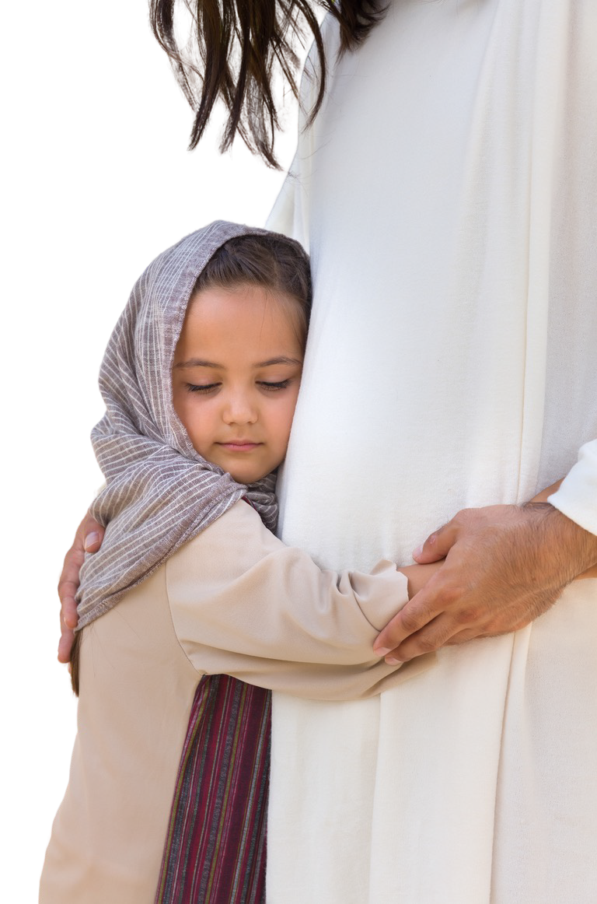

**NOVEMBER 18, 2023**

WORLD ORPHANS AND VULNERABLE

CHILDREN’S DAY

Adventist Children’s Ministries

General Conference of Seventh-day Adventists

Photo credit: Canva



# Sermon: Hope in a Foreign Land

### (Continued)

A child said to me once. “It was so fun to sit on the donkey for Mary. Only Joseph needed to walk and got tired alone!” Some might say that she got to sit on the donkey. But let me tell you that sitting on donkey for a day or two is not like sitting comfortably in the air-conditioned car or van. Your whole body could be sore and much more for a pregnant woman. They must have felt sticky and dusty under the scorching heat and continually layered with sweat rolling down on their faces and entire bodies.

Whenever we read about the birth of Jesus, my children were always fascinated that on the pages describing the birth of Jesus, Mary was surrounded by barn animals. They pointed to the animals, identifying them by name and making animal sounds.

“Moo-Moo” is for the cows. “Cluck-Cluck” is for Chicken. “Hee-Haw” is for donkey. “Meow-Meow” is for cats. “Quack-Quack” is for ducks, and the list went on.

Imagine being born in such inconvenient place with noises everywhere. Although those sounds seem fun but when we hear them repeatedly, they could be an annoyance to us. While newborn babies need to sleep a lot, Baby Jesus would be waking up with every noise made by those animals if He felt insecure and unsafe. On the contrary, Jesus was having a very peaceful sleep because, not only Mary and Joseph were with Him, but also God’s presence and peace from within.

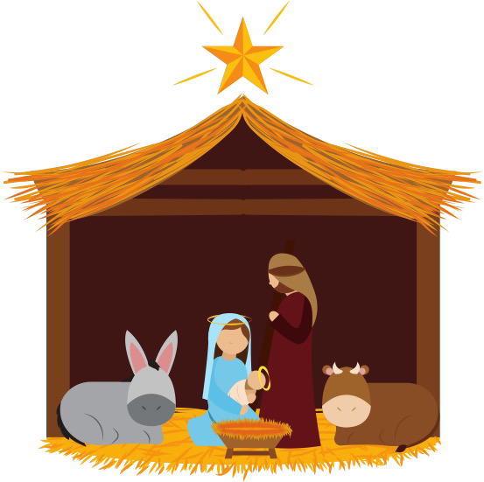Certainly, Jesus’s birth was not a normal birthing situation, and it has got us to ponder and think of multiple hardships Mary and Joseph endured. Not only were they unable to find a clean, warm, cozy, quiet and proper birthplace for Him, but shortly thereafter, this young family had to flee persecution and went away from King Herod’s reach. To attain safety, they had to flee to Egypt as refugees.



      

# Sermon: Hope in a Foreign Land

### (Continued)

The journey that Mary, Joseph, and baby Jesus took is not altogether unfamiliar to the millions worldwide who are forcibly displaced from their homes every year with 40 percent of them children. We do not hope in Christ abolishing all the conflict and injustice that force people to flee their homes, but in the knowledge that He came amid suffering Himself reveals to us the circumstances that any refugee child face today.

First, God’s incarnate Son was both a downwardly mobile migrant––he left the realms of heavenly comforts and pitched his tent among men. John 1:14 says, “And the Word became flesh and dwelt among us, and we have seen his glory as of the only Son from the Father, full of grace and truth. (ESV)

“Jesus knows intimately what it feels like to be a stranger in a foreign land. He identifies so much with strangers that when we welcome them, we are welcoming him.”

Second, He also lived as a refugee fleeing for safety. The Bible says in Matthew 2:13, “Now when they had departed, behold, an angel of the Lord appeared to Joseph in a dream and said, “Rise, take the child and his mother, and flee to Egypt, and remain there until I tell you, for Herod is about to search for the child, to destroy him.” (ESV). This verse tells us that it is uncommon people must leave his/her own birthplace as to protect themselves and their families. As the end time is approaching near so also the afflictions and tribulations upon God’s faithful people.

Third, Jesus knows intimately what it feels like to be a stranger in a foreign land. He identifies so much with strangers that when we welcome them, we are welcoming him. Elsewhere, we learn we could even be entertaining angels unaware when we enter relationships with strangers. Hebrews 13:2 instructs us, “Do not neglect to show hospitality to strangers, for thereby some have entertained angels unawares,” (EVS). In fact, Jesus is even touched and grateful if we warmly welcome strangers, refugee children, and their families and attend to their needs indiscriminately as He says in Matthew 25:35-40, that “For I was hungry and you gave me

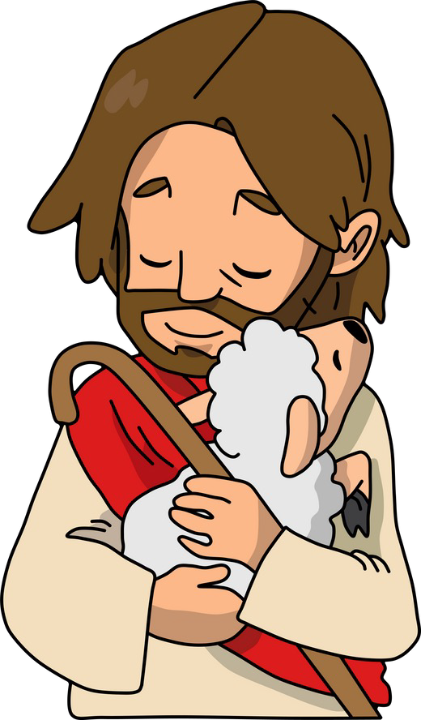



# Sermon: Hope in a Foreign Land

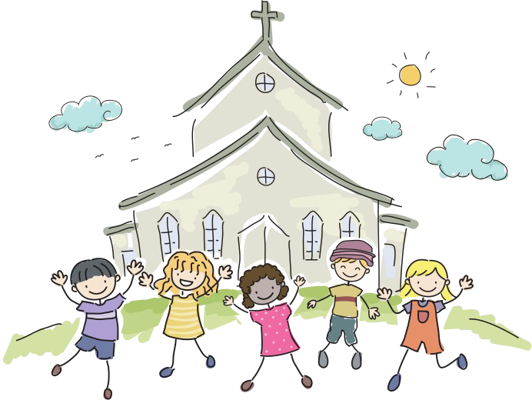

### (Continued)

Food. I was thirsty and you gave me drink, I was a stranger and you welcomed me, I was naked and you clothed me, I was sick and you visited me, I was in prison and you came to me.’ Then the righteous will answer him, saying, ‘Lord, when did we see you hungry and feed you, or thirsty and give you drink? And when did we see you a stranger and welcome you, or naked and clothe you? And when did we see you sick or in prison and visit you?’ And the King will answer them, ‘Truly, I say to you, as you did it to one of the least of these my brothers, you did it to me.’

Adventist Churches and other churches especially in the United States and around the world who are on the front lines of welcoming refugees are aware of these deep blessings. By loving and caring for our immigrant neighbors, we understand

“Refugees represent the very best of the human spirit. They need and deserve support and solidarity — not closed borders and pushbacks.”

more fully a God who works through every culture and circumstance to bring people together to be blessed and to know Himself.

We are able to both carry out the greatest commandment given to mankind which is to love our neighbors as much as we love ourselves, and this is God’s mandate found in Matthew 22:39. And through our effort of loving one another fully and tangibly, we are able to fulfill the Great Commission to make disciples of all nations according to Matthew 28:19 which says, “Go therefore and make disciples of all nations, baptizing them in the name of the Father and of the Son and of the Holy Spirit,” (ESV).

The UN Secretary-General Antonio Guterres once said, “Refugees represent the very best of the human spirit. They need and deserve support and solidarity — not closed borders and pushbacks.”1 We would certainly be amazed to receive significant encouragement from our refugee neighbors, many of them are vibrant believers in the faith. In serving and loving tangibly, we may possibly inspire other with our Christlike. A refugee child or orphan hopes to be loved, accepted and welcomed in the community and church. Every person deserves to have hope in Christ and let us be a part of fulfilling people’s hope.

1 https://[www.un.org/en/observances/refugee-day/messages.](http://www.un.org/en/observances/refugee-day/messages) Accessed November 7, 2023



**PRAYER FOCUS**

# Sermon: Hope in a Foreign Land

### (Continued)

character and His love and they, in return, inspire us with their faith and genuine friendship.

There is no doubt that Jesus’s birth gives us hope that despite the challenging circumstances we face personally or societally, we can always find healing––and feel at home anywhere with Jesus.

Hope can be found everywhere, even in the most unexpected of places. After all, it only takes the form of a refugee and fragile child in a manger to keep our hearts burning with hope and our desire be open to the possibilities of God working in and through all challenges in our life circumstances. Sorrow and joy are integral parts of refugee child’s life journey, but the birth of Jesus story is a powerful reminder that our challenging circumstances do not dictate and have the final word to one’s life journey. Jesus does.

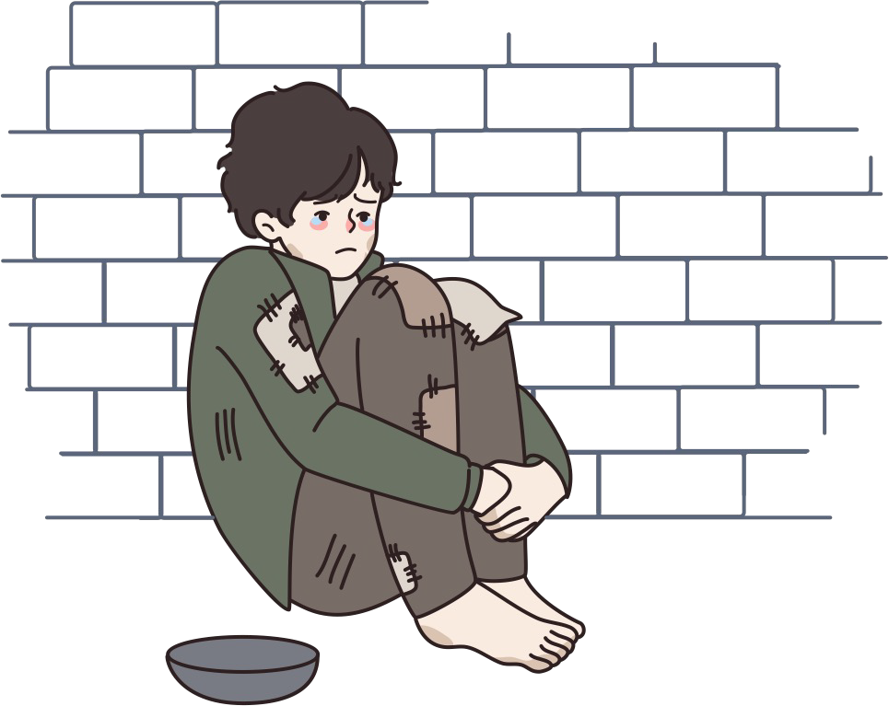



Adapted from an article written by Julie Hefti (2017). “Using art as therapy for orphans and vulnerable children.” Footsteps 101 by Christian Medical Association of India.

https://issuu.com/cmai/docs/fs101_web/s/11216587. Accessed November 7, 2023.

Children who have gone through difficulties and challenges need help for healing. Creating art and talking about it can help children help from them. Activities may include drawing, modeling, painting, collage and other type of art that can be provided for them. The suggested activities below are simple to follow and effective in helping orphans and vulnerable children to express their feeling, emotions, grow their positive self-esteem and work through difficult memories.

First and foremost is that the caregiver needs to be attentive and listen well. Children needs to let go, and one way is for them express their traumatized experiences in a safe and relaxed environment with someone who truly take an interest in them and their well-being and care for them deeply.

#### Before You Begin

You need to be prepared to work with such children. Find out details of each child from the person who are working with them and know them well before you begin.

If children show signs of distress, stop the activity and comfort them. You must consider arranging appointment for them with the certified counselor.

#### Art Idea #1

A good place to start with children who have gone through unpleasant and traumatized experiences is to get them to draw a “Safe Place.” It is also useful for children who are becoming anxious and developing anxiety.

You may encourage the child to close his eyes and image a safe place. Guide their thought by asking him to come up with an imaginary place that he feels very safe about and include only people he would like to be there. Give him plenty of time to imagine. Ask questions: What do you see? What do you smell? What do you hear? What are you doing? What else? When the child finishes imagining his safe place, he could draw or create it with coloring pens, pencils paints or different materials that can be found.







## Art Ideas for Orphans and Vulnerable Children

(Continued)

**Art Idea #2**

The purpose of this activity is to to help strengthen a child’s sense of identity and help build self-esteem.

Prepare a big mirror. Get the child to look in a mirror and while he is still looking at the mirror, ask the following questions:

* What do you see?
* Who created you?
* How many people in the world look exactly like you? You may point out that God created each child in a unique and special way. He has made sure that none is exactly alike us. Even our fingerprints and deep inside our genes are unique. Everything from the hands of God is beautiful and this includes every child.
* What do you look like? Can you describe yourself?
* What do you like about yourself? What is special?

Then create a piece of artwork with the child on this theme. Here are some suggested ideas that an be used.

* Use non-toxic paint or ink, get the child to make a handprint in the middle of a piece of paper and ask the child to write on or around the handprint “I am unique.”
* Encourage the child to write on every finger on the paper something that he likes about himself.
* Measure the child and write the result on the paper with the date. Tell the child that they are growing, and their height will soon be different. God is taking care of each one and He wants us to grow to love himself and be happy.

#### Art Idea #3

This activity is to help children deal with traumas and frightening things that have happened in their life.

This activity is to simply allow the child to draw or paint whatever he chooses and express your interest in what they create. This will help the children to express their thought and feelings without restrictions. Ask questions such as, ‘Tell me about your picture’, ‘Who is in it?’ and what are they doing?’ If this reveals the child is feeling afraid, you can use the following activity.







(Continued)

Use story telling technique to distract his attention. At the same time, motivate the child through the object lesson of the story for bravery and courage with God as the source of power, blessings, and courage.

* Tell the child about people or animals who were very afraid of something. During this situation, something happened with God’s intervention that He brought God’s peole out of danger. You may use the story of Israelite being captured and enslaved in Egypt. They felt worthless and were in great suffering. It was only by God’s intervention through Moses that they were set free.
* The story of the spies sent into Jericho and Joshua are also good one to help kids feel empowered and realize that they are not alone in facing all difficulties in life.
* Another powerful story is the story of Jesus calming the storm. While

the disciples were afraid, Jesus was sleeping soundly and peacefully. Tell children that He was not careless but He was brave because He knew that God was always with Him.

At the end, children should be able to develop an insight that life circumstances vary and beyond our control. And there are times that some people face greater challenges than others, but with God’s added strength and our trust in Him, we may stay calm and be able to live with peace.

* Then go back to the picture that the child drew of the situation that he felt afraid. Ask him what helped him in this situation and how his fear left. If the child could not imagine anything that could help him, try asking this question: ‘ What would havv helped you?’ Then ask the child to draw this person or things that helped onto the picture, so that it changes the memory.
* 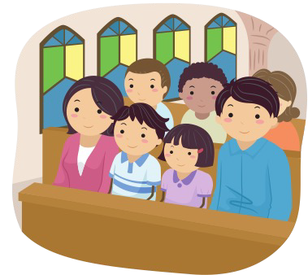Always end with prayer and tell them that they have done well and you would really like to see them again.





 